Saturday Science Lesson Plan
February 27, 2010

A) Learning Objectives
- Students will talk about ways water changes the land in front of the class.
- In groups of 4, students will pour, sprinkle, and squirt water onto a sand surface to change what they sand surface looks like.
- Students will draw three pictures of the sand surface before, during, and after is it exposed to water in their journals.
- Students will write their observations their journals to provide evidence for their inference of what erosion is.
- Students will point to 1 erosional feature outdoors to their Instructor to provide evidence for their inference of what erosion is.
- Students will point to 1 pollution feature outdoors to their Instructor to provide evidence for their inference of what erosion is.

B) Standards
- National Science Education Standards
  - K-4 Science as Inquiry: Abilities necessary to do scientific inquiry
  - K-4 Science as Inquiry: Understanding about scientific inquiry
  - K-4 Earth and Space Science: Properties of earth materials
  - K-4 History and Nature of Science: Science as a human endeavor
- Indiana State Academic Standards
  - K.1.1 Raise questions and the natural world
  - K.1.2 Begin to demonstrate that everybody can do science
  - 1.1.2 Investigate and make observations to seek answers to questions about the world
  - 2.1.3 Describe, both in writing and verbally, objects as accurately as possible and compare observations with those of other people
  - 2.1.4 Make new observations when there is a disagreement among initial observations
  - 2.1.5 Demonstrate the ability to work with a team but still reach and communicate one’s own conclusions about findings
  - K.2.2 Draw pictures and write words to describe objects and experiences
  - 1.2.7 Write brief information descriptions of a real object, person, place, or event using information from observations
  - 1.3.4 Investigate by observing, and then describe how things move in different ways, such as straight, zigzag, round-and-round, and back-and-forth

C) Content Knowledge
- Erosion is the process by which materials of the Earth’s crust are loosened, dissolved, or worn away and simultaneously moved from one place to another.1
- Erosion is caused by natural forces, such as water or wind, and artificial forces, such as human movement and deforestation.
- A noticeable area of erosion can be found in rivers and streams. In a river, the sharp cliff formed at the outer turn of a river bend is called a cut bank; in the cut bank, water moves with greater velocity and sediment is eroded away and washed into the river. The less steep, inner curve of a river bend is called a point bar; here, water is moving at a slower velocity and the sediment that is washed away at a cut bank is deposited at point bars, which results in their gradual slope. As rivers evolve and change their route, the cut banks continue to become eroded away until the bend is completely cut off and an oxbow lake, or U-shaped lake, is formed.

D) Materials
- 27 mechanical pencils
- 6 clear plastic storage bins
- 30 lbs sand
- 3 squirt-top water bottles
- 3 watering cans with perforated spouts
- 4-6 digital cameras
- 27 Water bingo cards
- Large chart paper

E) Lesson Description
- 9:35-9:40 Recap last week’s material with hanging chart (see below)
- 9:40-9:45 Discuss with students how water changes the land, write brainstorm on board
- 9:45-9:55 Explain erosion table activity, show materials, predict what will happen
- 9:55-10:15 Erosion table activity
- 10:15-10:20 Discuss what happened in activity, list ideas on board
- 10:20-10:40 Snack and bathroom break
- 10:40-10:55 “What does Water do to the Land?” PowerPoint. Introduce vocab words on word bank: erosion
- 10:55-11:00 Prepare to go outside, have students put on coats, pass out bingo cards, explain expectations for outside behavior
- 11:00-11:30 Walk around Wright building (see locations in Elaborate section below), take pictures of students next to erosional features
- 11:30-11:40 Discuss what we saw outside, list how Water Safety ideas on board
- 11:40-12:00 Student reflection activity

- 5-E Learning Cycle
  - Engage Instructors will ask the students “What do you remember about last week’s lesson?” to gauge cognition of the water pollution and safety. The Water Safety chart will be used (see below for schematic design) and we will begin to discuss how water’s affect on land can result in safe and unsafe situations. Instructors will ask attention-focusing questions such as “How do you think water changes the land?,” “What kinds of changes would you expect water to make on the land?,” and “How do you know water has changed the land?” Instructors will write down student’s ideas on the board in a brainstorming chart.

Is Our Water Safe?

  - Explore Students will explore how water changes the land through a hands-on activity. In groups of 4, students will receive a clear storage bin with a sand slope inside, 1 watering can, and 1 squirt bottle. Students will use various techniques of pouring, squirting, and sprinkling water on the land to see how the land changes; instructors will first model this in front of the class to demonstrate the importance of method, sharing, and cooperation. **Instructors and volunteers will be available at the stations to help answer student questions and to help in set-up.** Students will draw the changes that they see, such as shapes that the water makes in the sand, in their journals. Students will likely generate questions about “Why did the fast water change the sand more than the slow water?” and “Where does the sand go?”
  - Explain The class will discuss what happened in the erosion activity. Instructors will ask several action questions about the student’s experiments, such as “What happened when you sprinkled water on the sand with the watering can?”, “What happened when you dribbled water on the land with the squirt bottle?,” “What happened when you squirted the water out fast onto the sand?,” and “Where do you think the sand went after it was washed away?” Instructors will list student responses on the board and explain the rationales behind students’ observations about what happened to the sand. After snack, students will watch a PowerPoint presentation about erosion; this presentation will explain that streams, rivers, valleys, and canyons are all formed by erosion. Comparisons will be made between the erosion table activity and real-life examples. The vocabulary word “Erosion” will be added to the Word Bank and students will write their own definition of the word in their journals.
  - Elaborate Students receive Water Bingo cards and be explained the expectations for their outside exploration walk. Students will travel outside in groups of 6-7 with an Instructor; they will walk around the Wright building (see image below for planned walking path) and identify any pollution on the ground, pollution in the water, erosion, and/or evidences of water affecting the land that they see. Instructors will take a picture of each student with a feature that they find, as well as 1 group photo of their 6-7 students next to a pollution/erosional feature. During the walk, expected student-generated questions are “Is this an example of erosion?,” “How did that oil get there?,” and “Why is the river cutting the dirt like that?” Additionally, students are to try and find the 8 spots on their Water Bingo card (spots are: erosion, cut bank, trash in water, trash on land, oil on pavement, bridge, puddle, and dirty snow). After the walk, the class will return inside and discuss what features they saw in their groups. Students will generate ideas on how to be safe with these types of features, and Instructors will list their ideas on the board while students write/draw them in their journals.

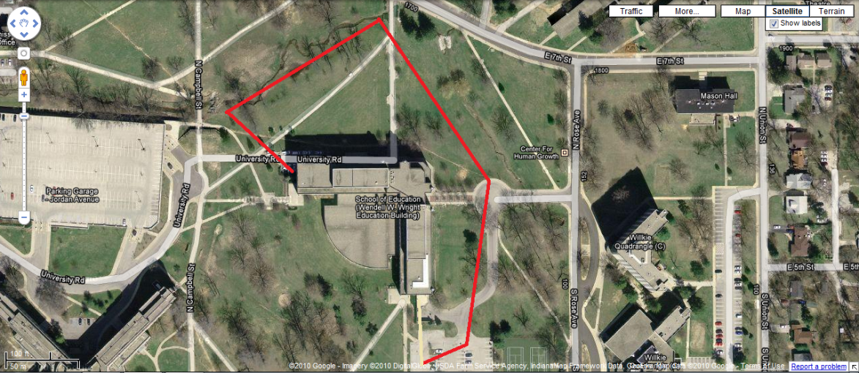2

  - Evaluate As students explore how different water speeds and droplet shapes change the land (as described in the Explore section), they will individually draw their observations in their journals. Students will draw what the land looks like before any water is added, after sprinkling it with the watering can, and after squirting it with a water bottle; they will record any shapes or patterns they see during these tests. Later in the session, students will travel outside to identify real-life examples of erosion and/or water pollution. Instructors will take pictures of each student next to a feature they identify, and this picture will be used to test student understanding of what erosion and pollution looks like (students will later use these pictures for a summative evaluation in Week 5). Finally, students will complete a metacognitive reflection of what they liked and didn’t like about their time in Saturday Science, as well as questions about water they think were answered and questions they still have about water that are unanswered; this reflection will be individually completed in their journals.
**A chart of the 4 types of learning covered in Weeks 4 and 5 will be included in the Week 5 Lesson Plan**

F) References
1 http://www.usgs.gov/science/science.php?term=353
2 Google Maps

